# Run 1

Camera Matrix

$$\left[\begin{matrix}1496.35 & 0 & 965.59 \\ 0 & 1497.01 & 476.61 \\ 0 & 0 & 1\end{matrix}\right]$$

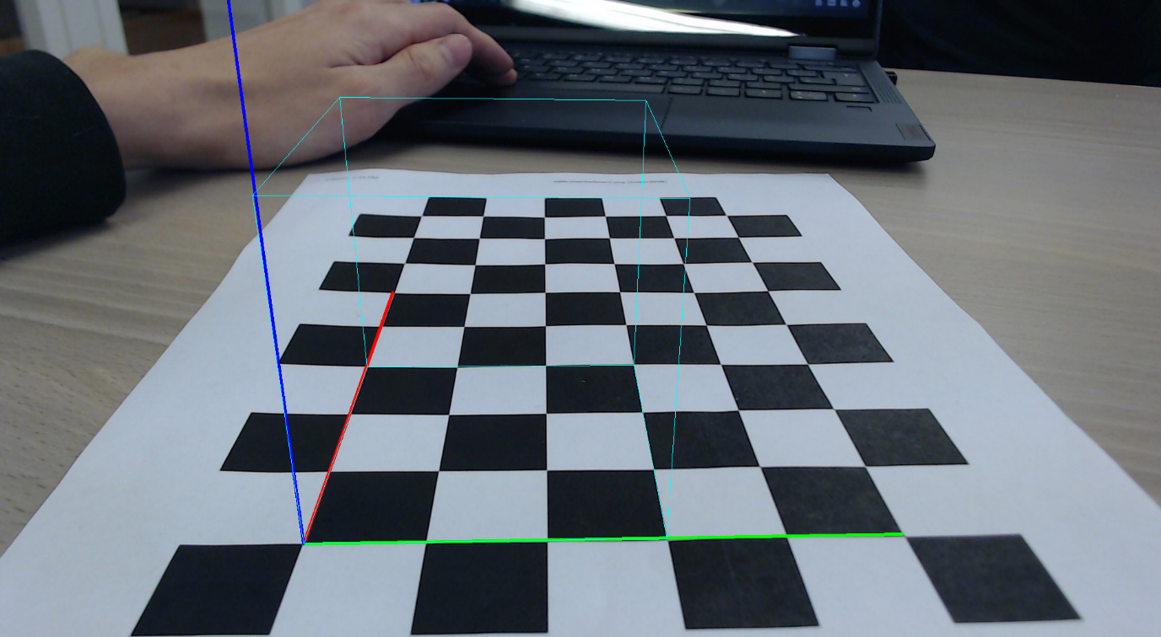

# Run 2

Camera Matrix

# Run 3

Camera Matrix

# Comparison

The biggest difference can be seen between (run1, run2) and (run1, run3). The focal length in both **Fx** and **Fy** have a difference of up to 50 units. The optical center **Cx** and **Cy** are also calculated slightly off. The overall quality drops significantly as the amount of input images is reduced. Due to the incorrect distortion calculations the Z coordinate gets more skewed the larger it becomes. In run 2 the left-side corners of the cube begin to shift apart from the center and a mismatch is seen between the XYZ axis and the side of the cube touching it. In Run 3 this effect is a bit more pronounced as the whole top part of the cube is slightly larger than the bottom part.

# Optional Implementations:

**10p** Video tracking -> Video Link: https://youtu.be/soPsHlQbr1s  
**10p** Corner point interpolation:  
To better acquire the exact dimension and transformation of the chessboard on the image we’ve used the function **getPerspectiveTransform()** to map a uniform set of points to the warped image. We achieve that in these steps:

* Select 4 corners in order on the image and get 2D coordinates from mouse selection point.
* Calculate the width and height of the image within the boundary of the 4 selected corners
* Using the rows and cols information and the width and height we can linearly expand an array of 2d coordinates to fit said dimensions uniformly.
* Using **getPerspectiveTransform()** using the 4 corners from the original image and 4 corners from the uniform array we get the transformation required to transform the uniform set to the warped set.
* We perform the transformation on each 2D point using **perspectiveTrasform()**

**10p** Image processing:

In some cases, such as when the chessboard is too bright or has some reflections, **findChessboardCorners()** doesn’t find the corners when provided with just a grayscale image. Therefore, an image preprocessing step has been added. The preprocessing consists of a binary threshold using Otsu’s algorithm, a dilation step with one iteration and a kernel of (1,1), and finally a linear 2D filter with kernel $\left[\begin{matrix}-1 & -1 & -1 \\ -1 & 9 & -1 \\ -1 & -1 & -1\end{matrix}\right]$ to smooth the edges.

The preprocessing step is not always applied, though. Only if **findChessboardCorners()** fails, the preprocessing step is applied, then **findChessboardCorners()** is run again on the preprocessed image. Should this fail, the manual corner finding step is used.